

POX – TT VALIDATION RULES

User Manual

www.projectobjects.com

support@projectobjects.com

Contents

1- Overview: 2

2- Setting up validation rules for Timesheet: 2

3- Timesheet Frequency: 3

3.1- Select Frequency: 3

3.2- Required User Interface (Week View): 3

3.3- Required User Interface (Month View): 3

3.4- Show Week Starting: 4

3.5- Week Within Month Only: 5

4 - Hours Setting: 5

5 - Sorting of project list into the timesheet: 5

6 – Manage Chargeable activity: 7

7- Show Activity Details pop-up on timesheet entry form: 8

8 - Show Comment pop-up on timesheet entry form: 9

9 - Show job title on timesheet entry form: 9

10 - Synchronization rules: 10

11- Attendance management: 11

11.1- Active Attendance Management: 11

11.2- Range between Attendance and Timesheet: 11

11.3- Enable Add cost center: 11

12 - Accounting Periods: 12

12.1 - open (none): 13

12.2- Current, Fixed: 13

12.3 - Specific Interval: 14

13 - Expense Tracking: 14

13.1- Expensesheet Periods: 14

14- Leave management: 15

# Overview:

Time-Tracking Application is the extension of PO functionalities, where users can fill time in timesheets against projects created in PO Application. Timesheets can further release to immediate senior for approval.

This Application primarily aimed at Timesheet Management, which enables access to the timesheets management operations: create, edit, release, approve, reopen, delete.

# Setting up validation rules for Timesheet:

TT validation Rules are the criteria used in the process of creating timesheets and expense sheets. This module allows for managing the behavior of Time Tracking Application. This form is where a period of creating timesheets (weekly, monthly) and grace period for creating expense sheets is defined.

TT Validation Rules can be configured at:

**Configuration >> TT Validation Rules**

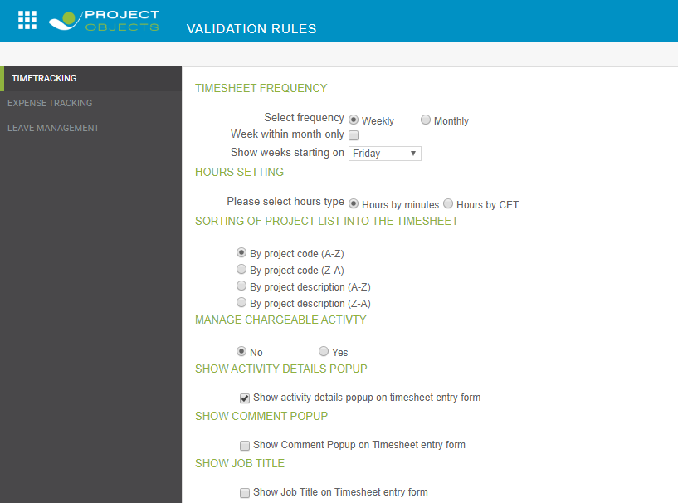

# timesheet Frequency:

Timesheet frequency specifies the amount of time each timesheet covers and therefore, how frequently timesheets are to be submitted.

## 3.1- Select Frequency:

Available timesheet frequency:

1. Weekly: Weekly timesheets will cover the duration of 7 days.
2. Monthly: Monthly timesheets will cover all days of the selected month.

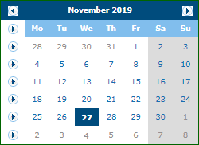

## 3.2- Required User Interface (Week View):

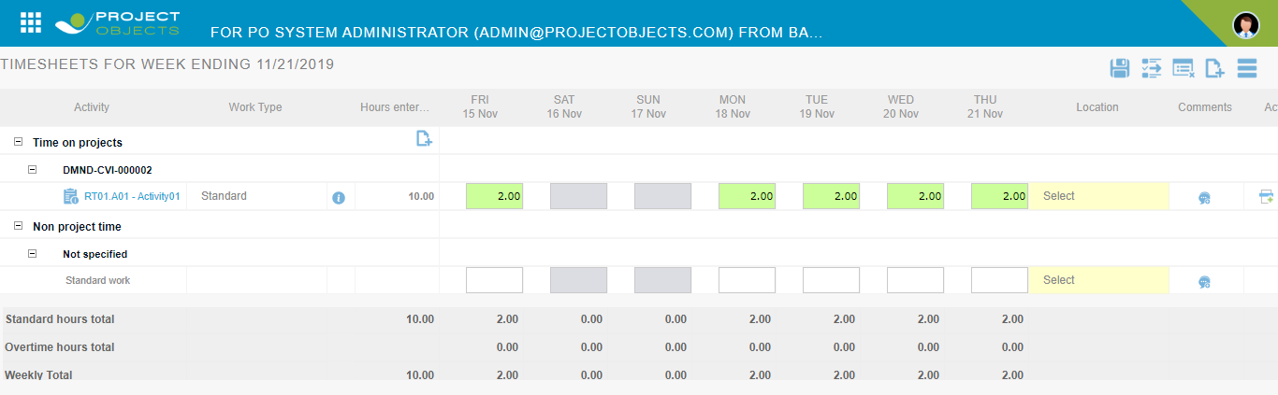

## 3.3- Required User Interface (Month View):

Monthly timesheet can either be viewed in month view or week view.

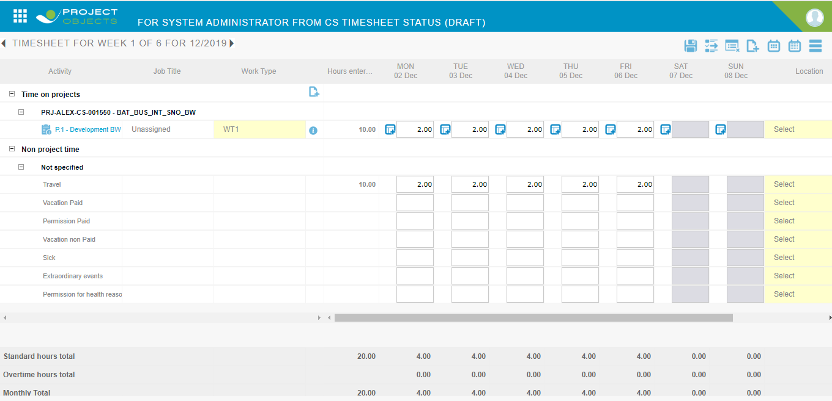

If the period is changed from weekly to monthly or vice-versa in a course of time, then newly created timesheets will be according to the new selected period and period of previous timesheets will remain the same.

## 3.4- Show Week Starting:

Start day of timesheet is selected from “Show week starting on” combo box. This combo is applicable when the week view is selected. The selected day will be the start day of the weekly timesheet form.

In case the start day is changed, then new timesheets will be according to the newly selected day and the start day in previous timesheets will remain as before.

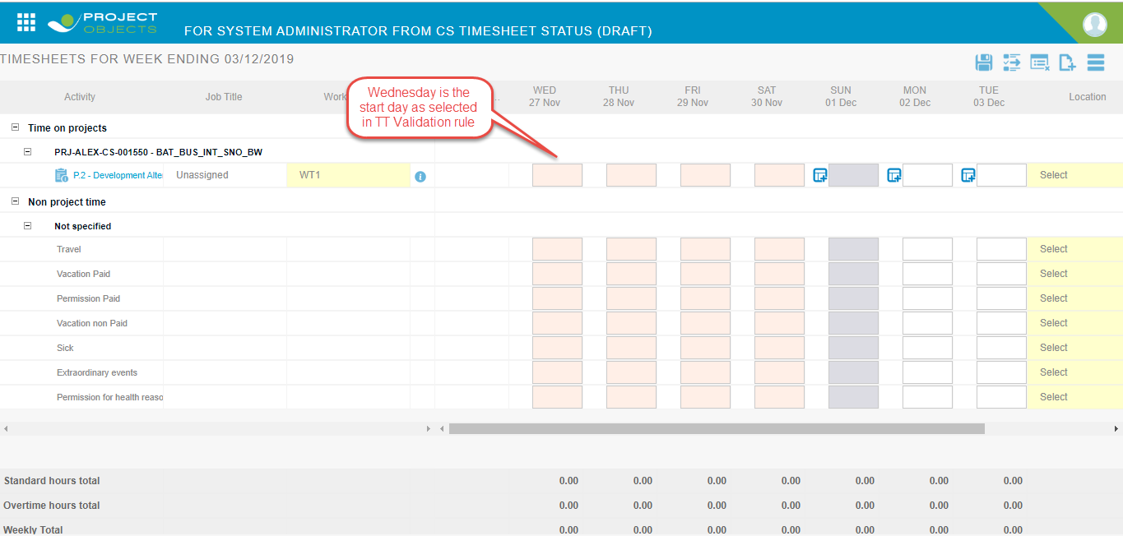

## 3.5- Week Within Month Only:

Weekdays that exist in the same month would be editable in timesheet form. For example, if a week starts from 30 December 2019 to 5 January 2020, then only 30 and 31 December will be editable on timesheet form.

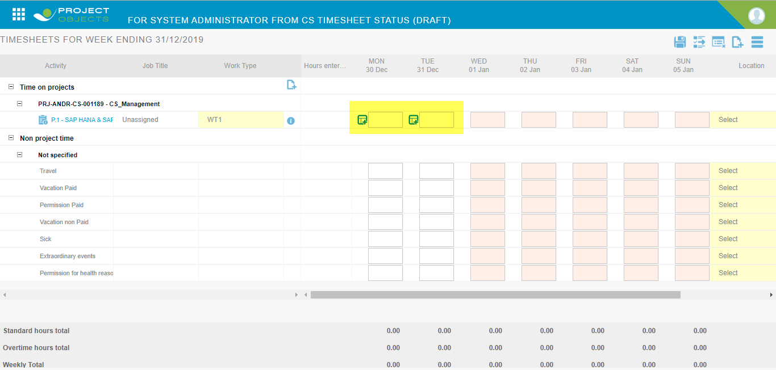

# 4 - Hours Setting:

From here a user can select hour type. Hour type can be of two types. We can understand it by an example, suppose a user wants to enter seven and a half hours in a timesheet.

1. Hours by minutes: If a user wants to fill seven and a half hour then the user will fill 7.30.
2. Hours by CET: If a user wants to fill seven and a half hours then the user will fill 7.50.

# 5 - Sorting of project list into the timesheet:

Sorting of project list in timesheet can be done in 4 ways:

1. By project code ( A-Z ): The project list will be visible in alphabetical order (from A to Z) of the project code.

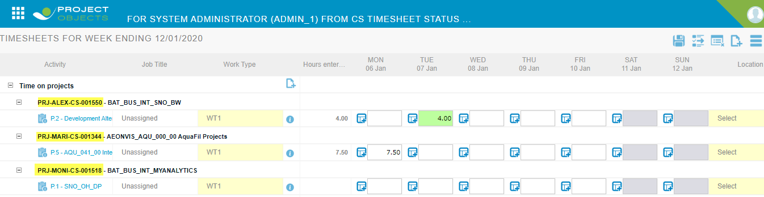

1. By project code ( Z-A ): The project list will be visible in reverse alphabetical order (from Z to A) of project code.

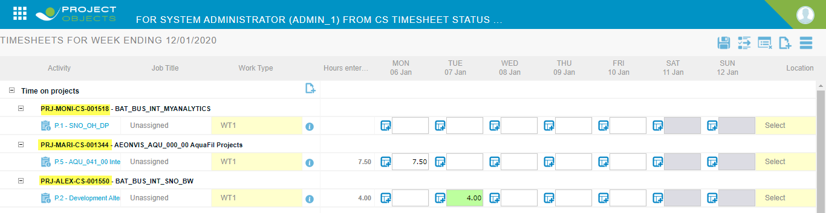

1. By project description (A-Z): Project list will be visible in alphabetical order (from A to Z) of the project description

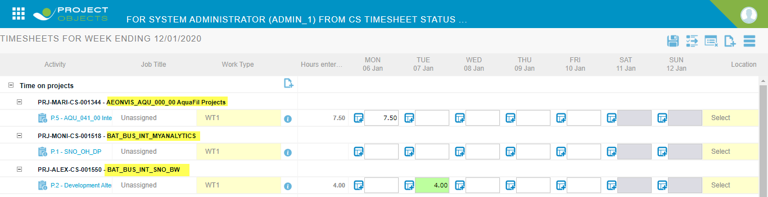

1. By project description (Z-A): The project list will be visible in reverse alphabetical order (from Z to A) of project code.

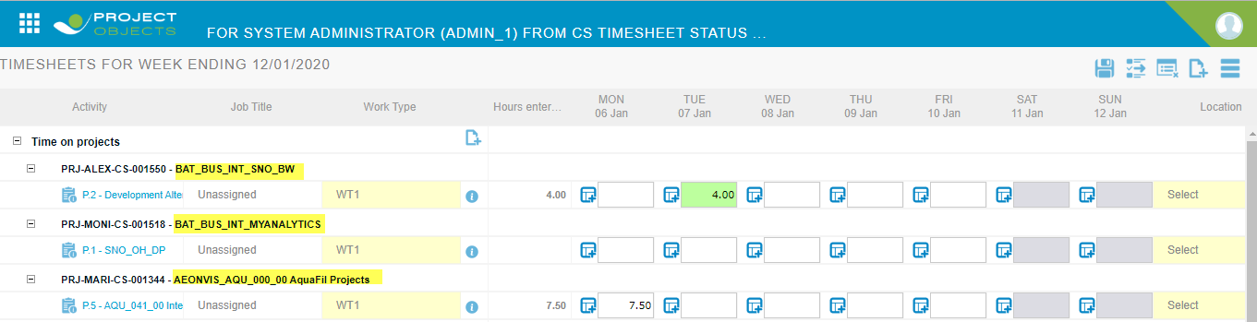

# 6 – MANAGE CHARGEABLE ACTIVITY:

Manage chargeable activity is used to manage activities in add activity pop-up of a timesheet entry form or used to manage activities chargeable.

If no is selected in tt validation rules then no activity will appear in the add activity pop-up.

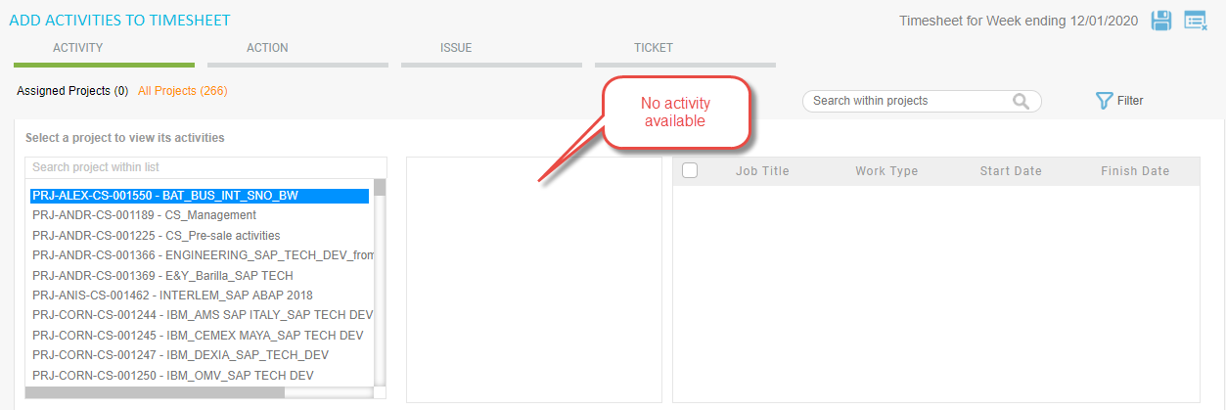

If yes is selected in tt validation rules and a user wants to make some activities chargeable then the user has to select yes in manage chargeable activity in edit activity popup.

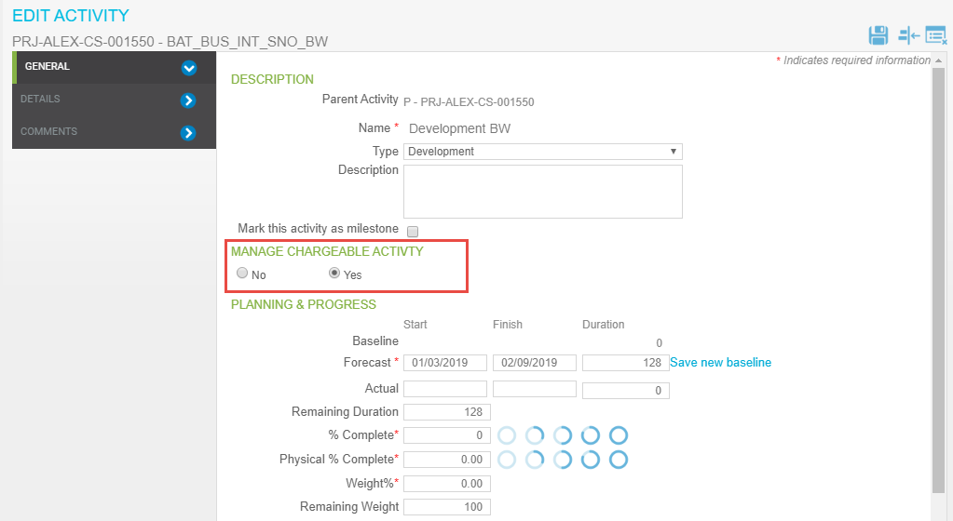

Now chargeable activity will appear in add activity pop-up of the timesheet entry form.

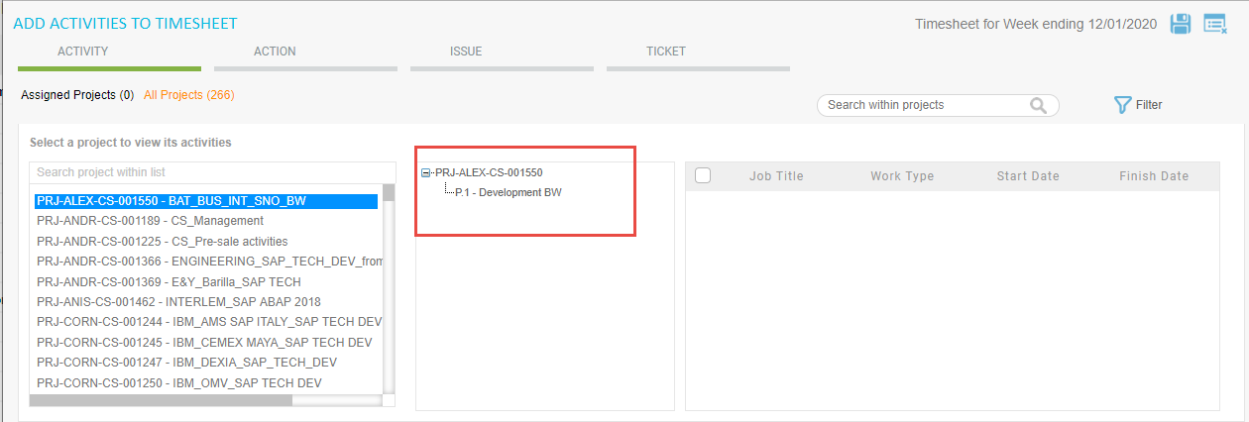

# 7- Show Activity Details pop-up on timesheet entry form:

Activity details pop-up change the way to enter hours in the timesheet. The selection of this section from TT validations, adds a new section of ‘Time Tracking’ on the project edit page.

Hence, the display of activity details pop-up will become project-specific.

**time tracking section:**

1. Fill timesheet with activity type: Activity details pop-up will display for the selected project.
2. Fill timesheet without activity type: Activity details pop-up will not display and hours will be entered directly in hour field.

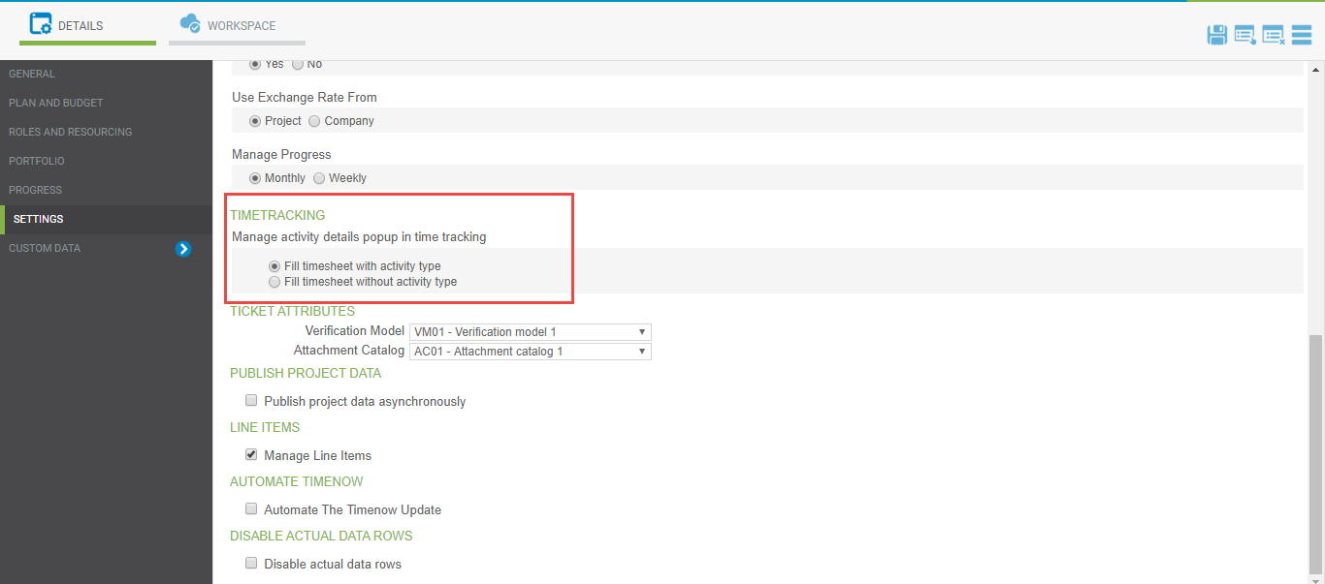

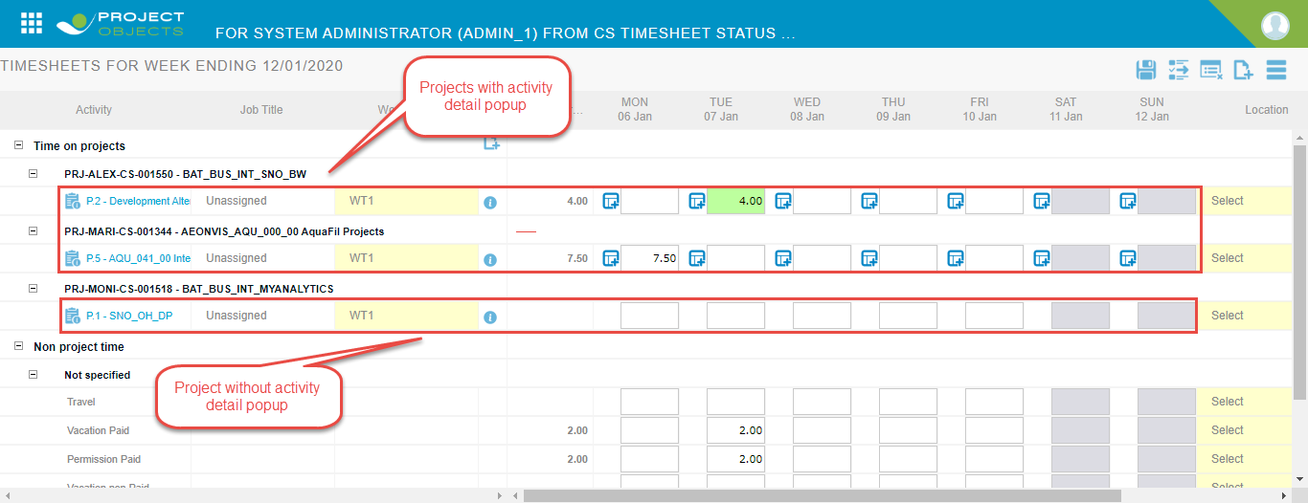

# 8 - Show Comment pop-up on timesheet entry form:

Selecting show comment popup on tt validation rules shows a comment pop on each cell of the timesheet entry form. Using this user can enter a comment on each cell of the timesheet entry form.

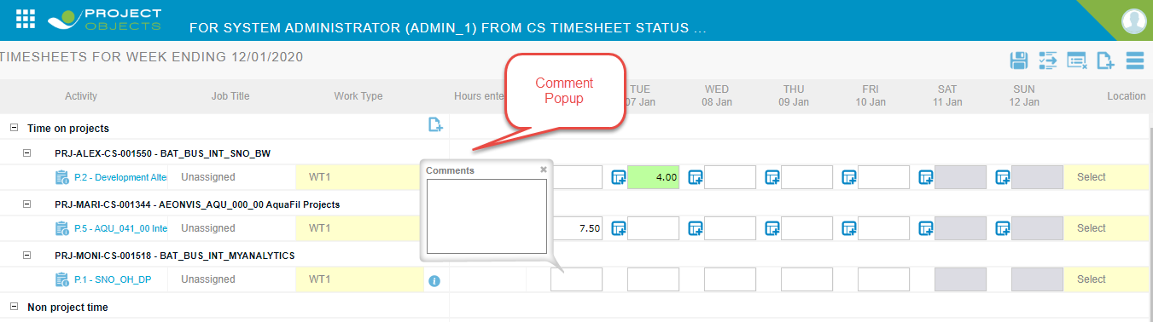

# 9 - Show job title on timesheet entry form:

Selecting show job title on timesheet entry form shows job title column in the timesheet entry form.

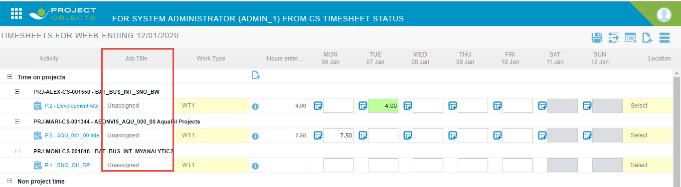

If show job title on the timesheet entry form is not selected then the job title column disappears.

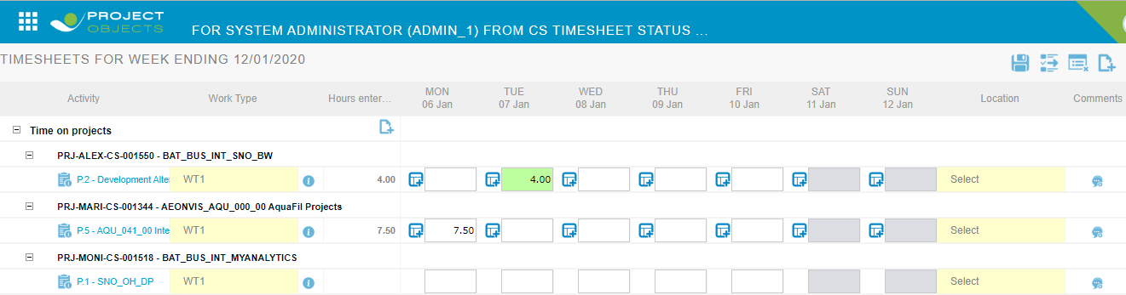

# 10 - Synchronization rules:

|  |  |  |
| --- | --- | --- |
| **S.No.** | **Rules** | **Description** |
| 1 | Automatically assign resources based on time tracking actuals | Resources get assigned automatically to the project if hours in timesheet are filled against that project.  *\* works even without a selection of this rule.* |
| 2 | Accept actuals even when they fall outside of planned activity dates | Actual hours get updated in the PO if hours are filled in timesheet with dates that fall outside of the start and finish date of activity/project.  *\*works even without a selection of this rule.* |
| 3 | Update physical progress in Progress Tracking based on time captured |  |
| 4 | Allow time to be captured on projects without activities being selected |  |
| 5 | Update resource’s actual work in Projects Objects based on time captured  1. When timesheets are saved as a draft.  2. When timesheets are released.  3. When timesheets are approved. | This is to update the actual hours in the PO.  1. Update actual hours entered in TS, in the PM module of PO application when TS is in draft state.  2. Update actual hours entered in TS, in PM module of PO application when TS is in release state.  3. Update actual hours entered in TS, in the PM module of PO application when TS is in the approved state after completing the workflow cycle. |

# 11- Attendance management:

Attendance Management will work over the monthly timesheet of resources. The process will compare the hours filled by resources in a timesheet to the hours punched within the attendance management system. On which basis a report will be prepared within PO Application to give details of resource work hours.

## 11.1- Active Attendance Management:

This is to activate the attendance management, when not checked attendance-management related changes will not be visible within the TT application.

## 11.2- Range between Attendance and Timesheet:

This field is to save the tolerance value in the format of HH.MM.

## 11.3- Enable Add cost center:

Selection of “enable add cost center” on tt validation rule page enables add cost center icon on timesheet entry form.

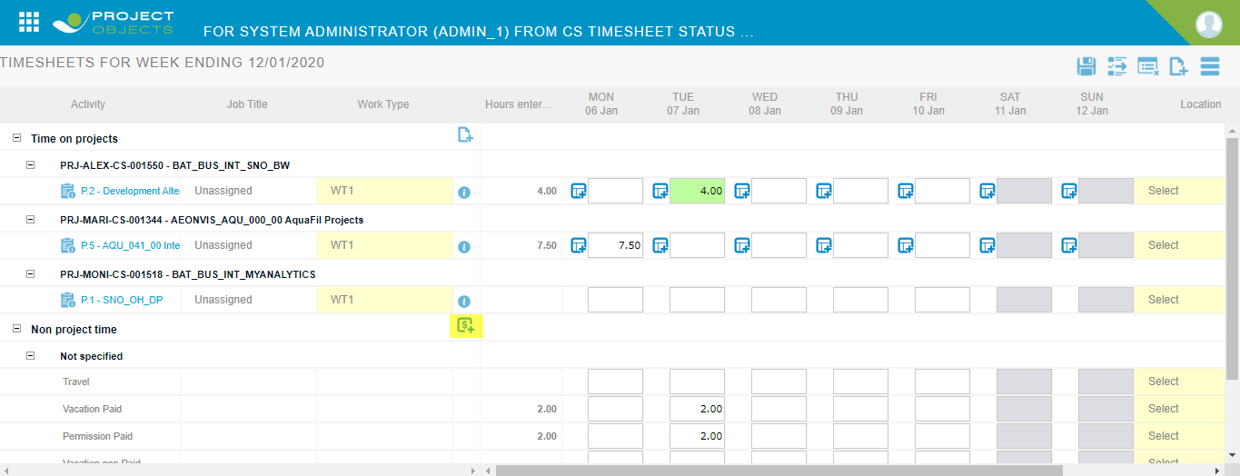

Now click on add cost center icon and select cost centers from add cost centers popup, click on save icon, now selected cost centers will appear in the timesheet entry form.

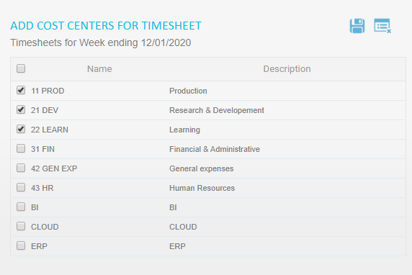

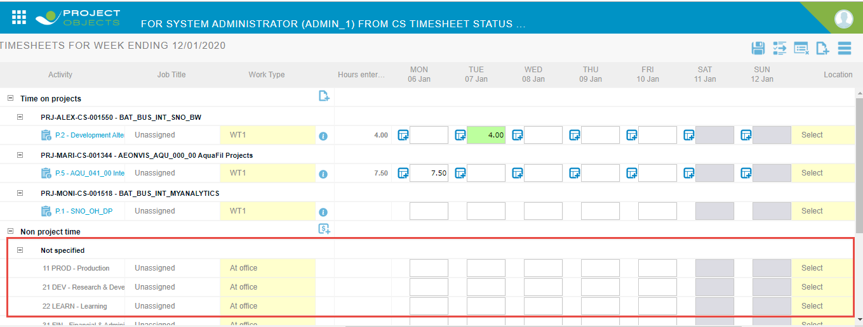

# 12 - Accounting Periods:

Accounting periods define the period of time in which a user can create a timesheet. There are 3 types of accounting periods:

1. Open (none)
2. Current, fixed
3. Specific interval.

## 12.1 - open (none):

The selection of this accounting period in TT validation rules allows a user to create a timesheet for any time period.

## 12.2- Current, Fixed:

Selection of this accounting period in TT validation rules allows a user to create timesheet from current to a fixed time period in the following ways:

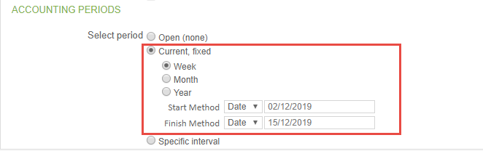

1. Week: this time period allows the user to create a timesheet for the weeks' date selected in the start method to date selected in the finish method. From the above figure, we can see users can create timesheets for the weeks starting from 2/12/2019 to 15/12/2019.

Similarly, users can select “value” in place of date in the start method and finish method. From the below figure we can see users can create timesheets for the 2 weeks before the current time and 2 weeks after the current time.

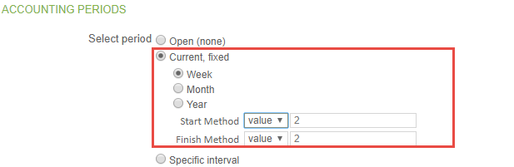

1. Month: Similar to week, this time period allows the user to create timesheets for the months' date selected in the start method to date selected in the finish method.
2. Year: Month: Similar to week, this time period allows a user to create timesheets for the year date selected in the start method to date selected in the finish method.

## 12.3 - Specific Interval:

The selection of this accounting period in TT validation rules allows a user to create a timesheet for specific time periods defined from the start date to the end date.

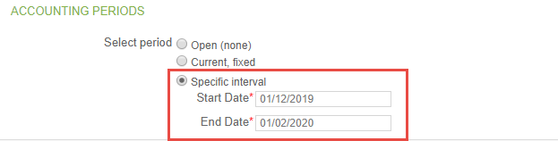

# 13 - Expense Tracking:

## 13.1- Expensesheet Periods:

The expense sheet period defines the range that the expense sheet must cover.

There are two options:

1. **Open:** Expense sheet of any duration from any month can be created.
2. **Current:** This is associated with the grace period and further has 2 options:
3. **Week:** Resource will only be able to create an expense sheet for the current week.

**Grace:** If grace period defined then resource can create expense sheet of the previous week up to the days mentioned in the grace field.

1. **Month:** Resource will only be able to create an expense sheet of any duration but within the current month.

**Grace:** If grace period defined then resource can create timesheet of the previous month up to the days mentioned in the grace field.

# 14- Leave management:

This particular setting is used in the leave management application. If we define grace period for this setting then it works as follows:

For example, if a user is on leave from the 10th of December to the 15th of December and grace period is defined 5, then after 5 days of leave period i.e 20th of December it will show a reminder according to company policies.